Q.1 What is javaScript. How to use it?

ANS :

javascript (js) is a light-weight object-oriented programming language . used by several website for scripting the webpages. it is an interpreted, full-fledged programming language that enables dynamic interactivity on websites when applied to an HTML document. it was introduced in the year 1995 for adding programs to the webpages in the netscpe navigator browser. the traditional website uses js to provide several forms of interactivity and simplicity.

javascript helps the user to build modern web application to interact directly without reloading the page every time. javescript is commonly used to dymanically modify and CSS to update a user interface by the DOM APL. it is mainly used in web applications.

Q.2 How many type of Variable in Javascript?

ANS :

there are 3 types of variables in javascript:

1. var :-

this is the oldest and most common way to declare a variable. variables declared with var are function-scoped, which means they can be accessed from anywherer within the function they are declared.

2. let :-

this is a newer way to declaer a variable . Variables declaered with let are block-scoped, which means they can only be accessed from within the block of code in which they are declaered.

3. const :-

this is newest way to declaere a variable . variable declaered within const are constant, which means they cannot be reassignned once they have been initialized.

Q.3 Define a Data Types in js?

ANS :

two types of data types: primitive and Non-primitive(refrence)

1. primitive type :-

* Number
* string
* Boolean
* Null
* Undefined

2.non-primitive (Reference) type:-

* Object
* Array
* Date

Q.4 Write a mul function Which will Work properly When invoked With Following Syntex.

ANS : the MUL function is a miniature of the multiplication. in this function, we call the function that required an argument as a firstvnumber, and that function calls another function that required another argument and this step gone on.

The first function’s argument is x, the second function`s argument is y and the third is z, so the return value will be xyz.

syntex :

function mul (X) {

return function (Y) {

return funtion (Z) {

return X * Y * Z;

};

};

}

Q.5 What the deference between undefined and undeclare in javascript?

ANS :

Undeclared variables are those that have not been declared or defined in the current scope, while undefined variables are those that have been declared but not given a value.

Undefined: It occurs when a variable has been declared but has not been assigned any value. Undefined is not a keyword.

Undeclared: It occurs when we try to access any variable that is not initialized or declared earlier using the var or const keyword.

Q.6 Using consol.log() print out the following statement:the quote 'there is no exercise better for the heart than reaching down and lifting people up.' by john holmes teaches us to help one another. using console.log()print out the following quote by mother teresa:

ANS :

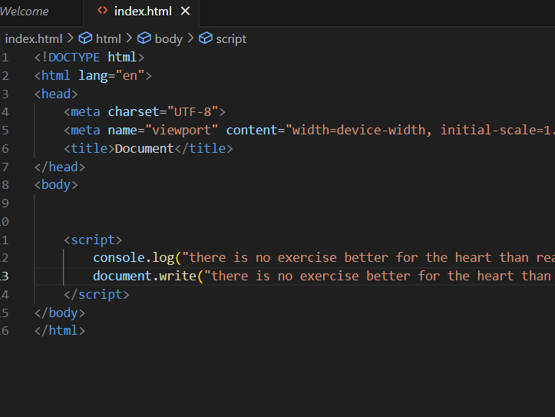

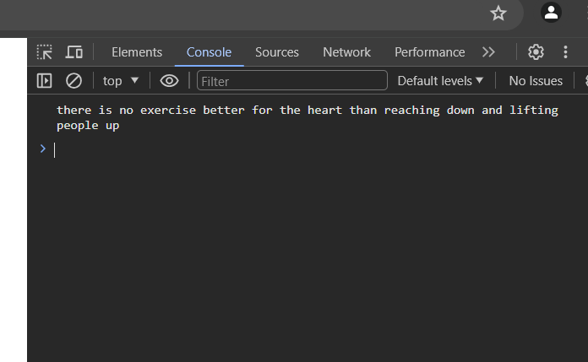

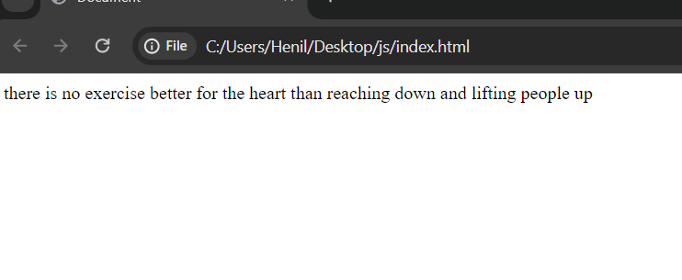

Q.7 Check if typeof '10' is exactly equal to 10. if not make it exactly equal?

ANS :

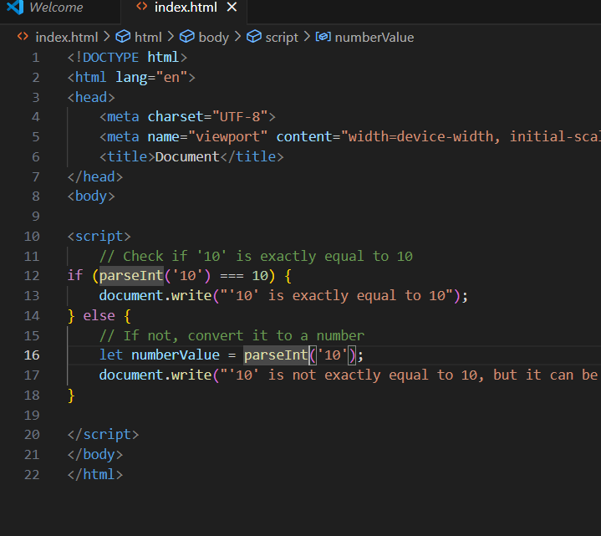

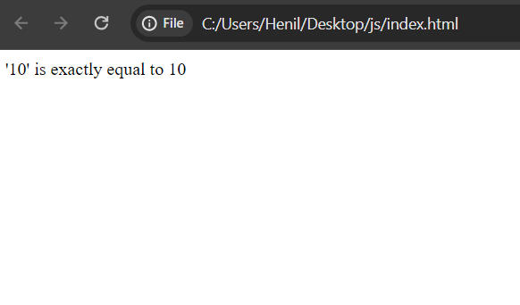

Q.8 Write a javascript program to find the area of a triangle?

ANS :

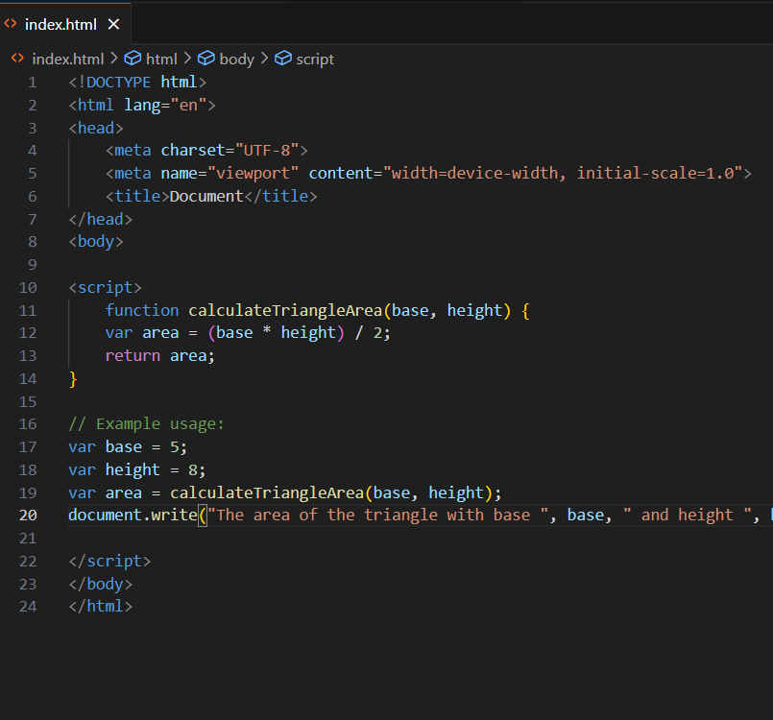

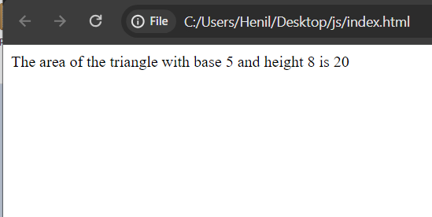

Q.9 Write a javascript program to calculate days left until next Christmas?

ANS :

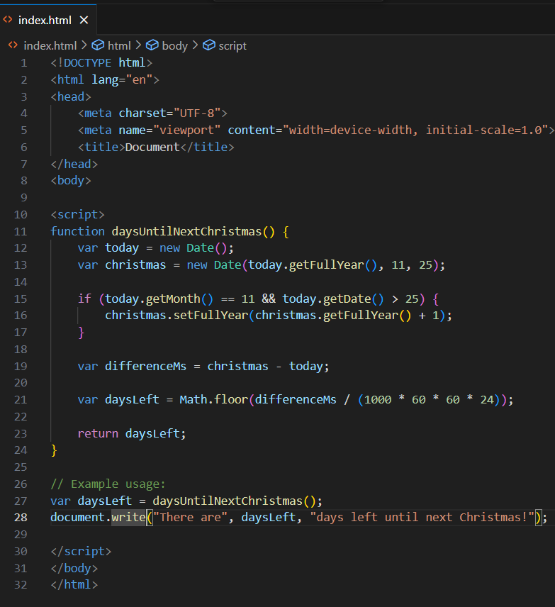

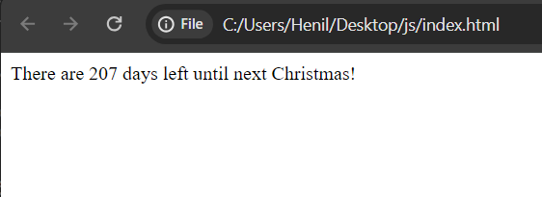

Q.10 What is condition statement?

ANS :

A condition statement, also known as a conditional statement or an "if statement," is a fundamental concept in programming that allows a program to make decisions based on certain conditions. It enables the program to execute different blocks of code depending on whether a specified condition evaluates to true or false.

Q.11 Find circumference of Rectangle foemula : C=4*a ?

ANS :

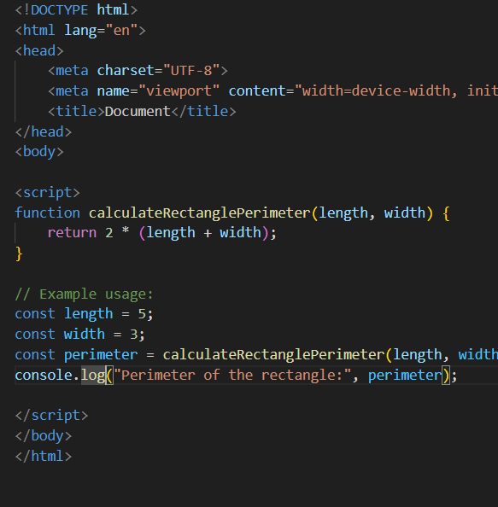

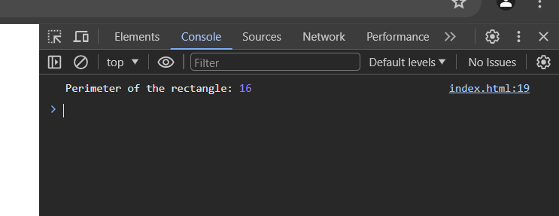

Q.12 WAP to convert years into days and days into years ?

ANS :

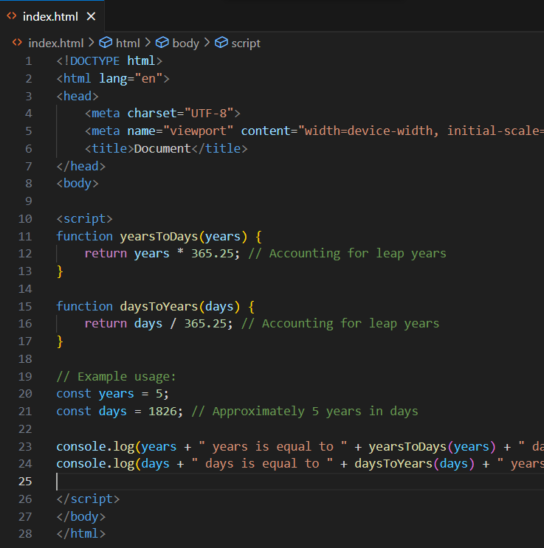

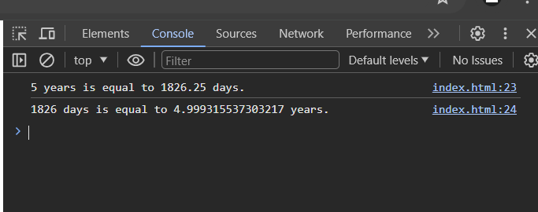

Q.13 Convert temperature Fahrenheit to Celsius ? (Condotional logic Question)

ANS :

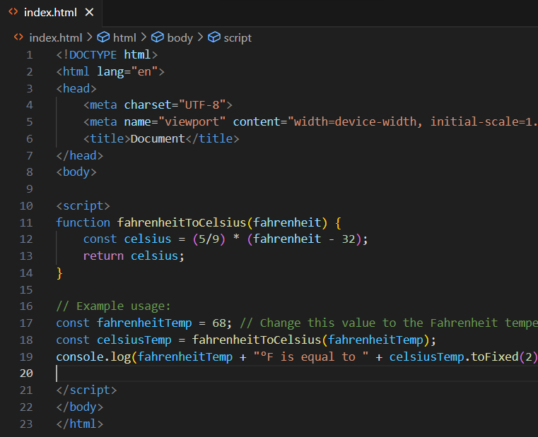

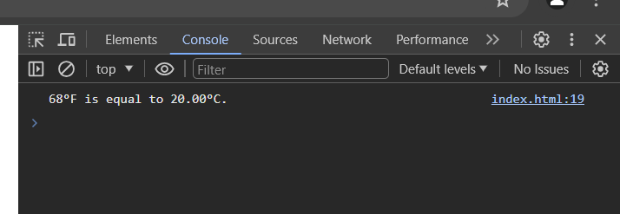

Q.14 Write a javascript exercise to get the extension of a filename.?

ANS :

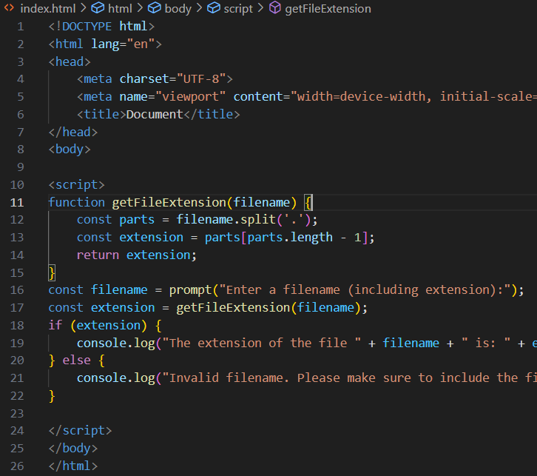

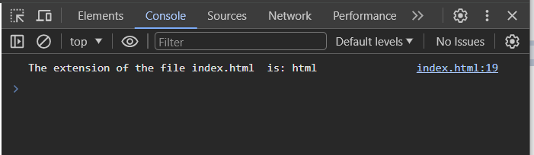

Q.15 What is the result of the expression(5>3 && 2<4)?

ANS :

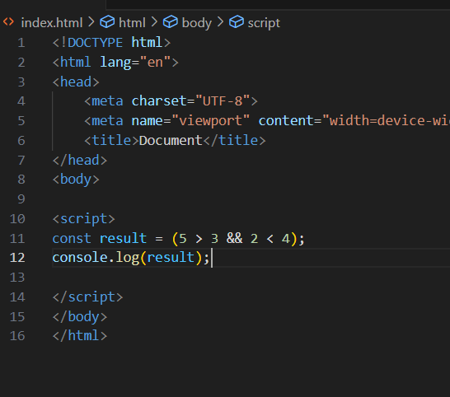

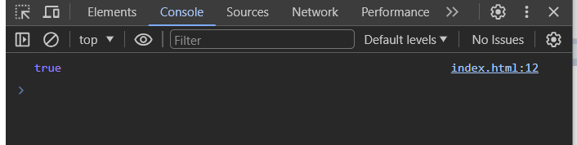

Q.16 What is the result of the expression(true && 1 && "hello")?

ANS :

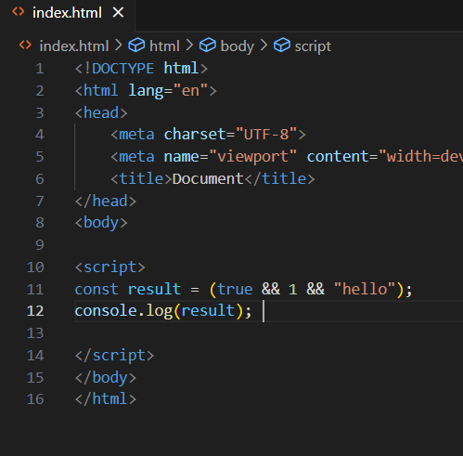

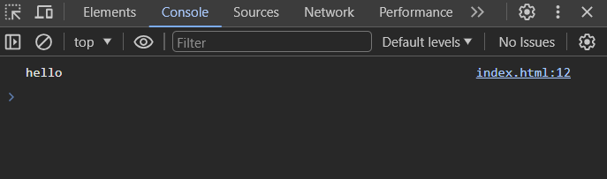

Q.17 What is the result of the expression true && false || false && true ?

ANS :

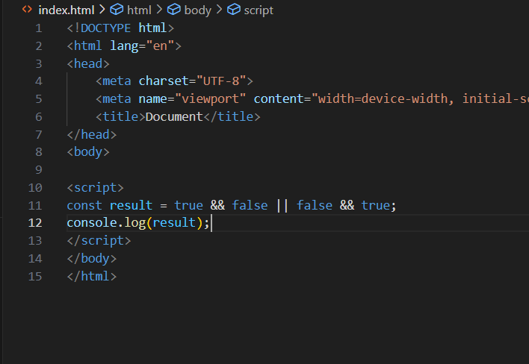

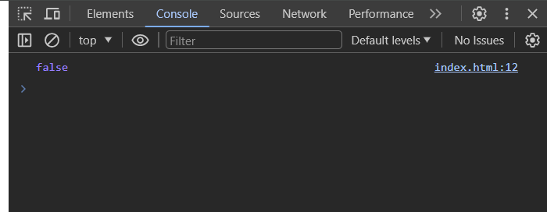

Q.18 What is a loop and switch case in javascript define that?

ANS :

Loop:

A loop is a programming construct that allows you to repeatedly execute a block of code multiple times. In JavaScript, there are several types of loops, including the for loop, while loop, and do-while loop.

Switch Case:

The switch statement is used to perform different actions based on different conditions. It evaluates an expression, then matches the expression's value to a case clause and executes the statements associated with that case.

switch (expression) {

case value1:

// code block to be executed if expression is equal to value1

break;

case value2:

// code block to be executed if expression is equal to value2

break;

default:

// code block to be executed if expression is not equal to any of the case values

}

Q.19 What is the use of is Nan function?

ANS :

The isNaN() function is used to check if a value is NaN, which stands for Not a Number. NaN is a special value that is returned when a mathematical operation results in an undefined or unrepresentable value. For example, dividing zero by zero results in NaN

The isNaN() function can be used to handle errors in mathematical operations. For example, the following code will print "Error" if the user enters a non-numeric value:

Q.20 What is the difference between && and || in javascript ?

ANS :

In JavaScript, && and || are logical operators used for performing Boolean logic operations. They are often used to combine or evaluate conditions in conditional statements, loops, and other control structures.  
 The AND operator has a higher precedence than the OR operator, meaning the && operator is executed before the || operator

Q.21 What is the use of void (0) ?

ANS :

JavaScript void 0 means returning undefined (void) as a primitive value. You might come across the term “JavaScript:void(0)” while going through HTML documents. It is used to prevent any side effects caused while inserting an expression in a web page.

The void operator in JavaScript evaluates the expression following it and then returns undefined. Its primary use is to create a hyperlink that performs a JavaScript action when clicked without navigating to a new page.

Q.22 Check number is positive or negative in javascript ?

ANS :

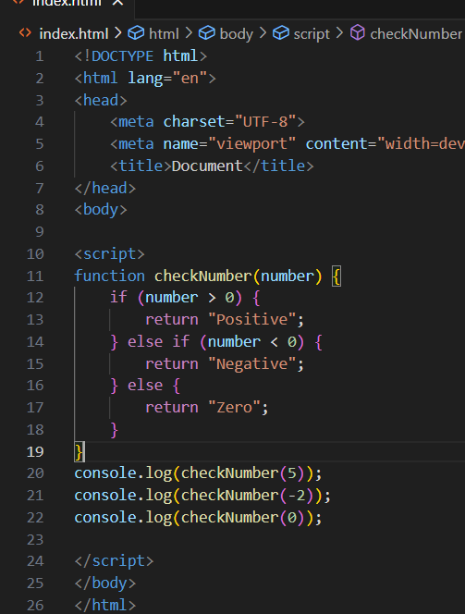

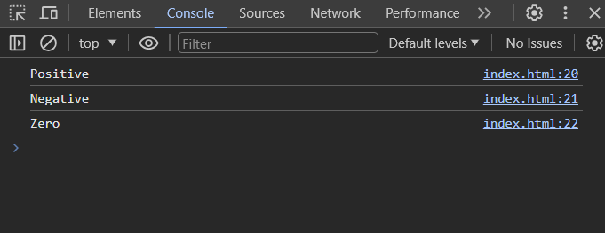

Q.23 Find the Character is Vowel or Not ?

ANS :

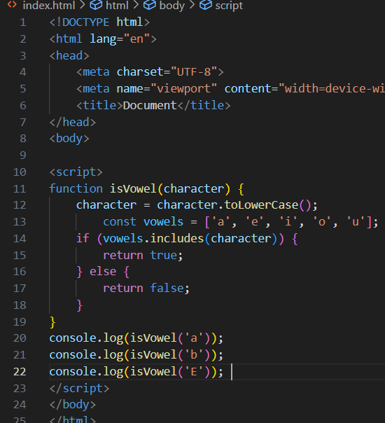

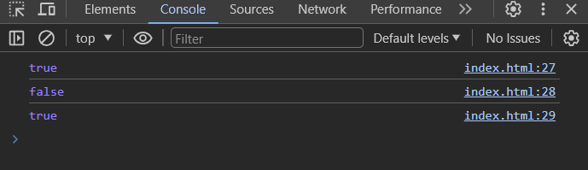

Q.24 Write to check whether a number is negative ,positive oe zaro ?

ANS :

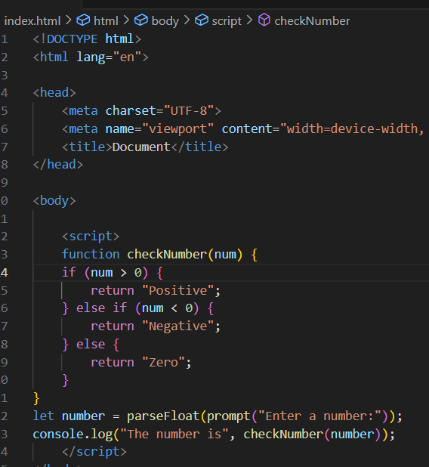

Q.25 Write to find number is even or odd using ternary operator in js?

ANS :

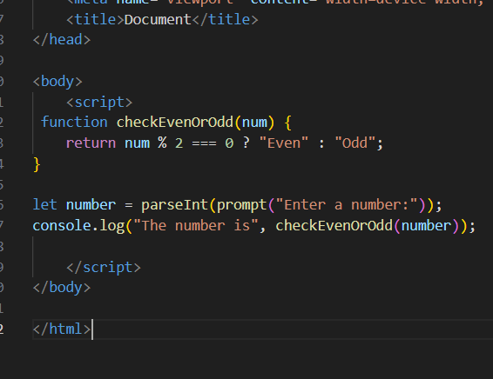

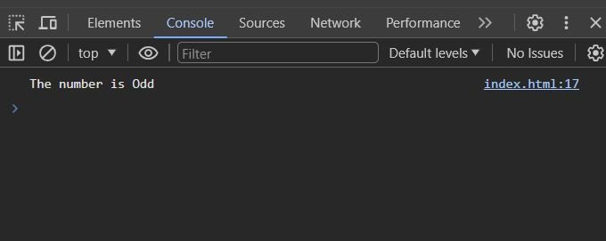

Q.26 Write find maximum number among 3 number using ternary operator in js?

ANS :

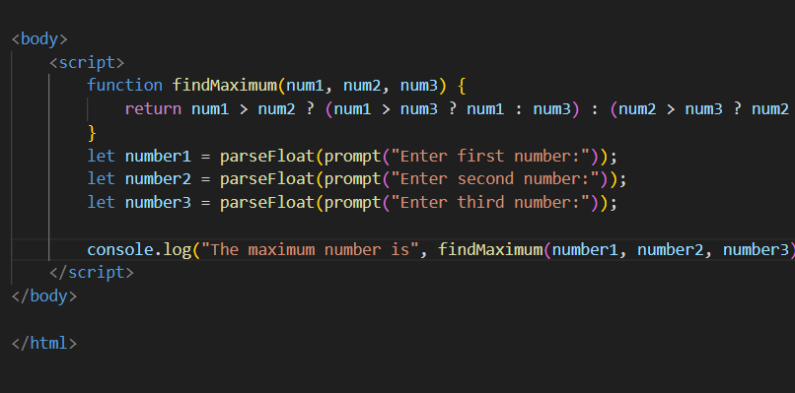

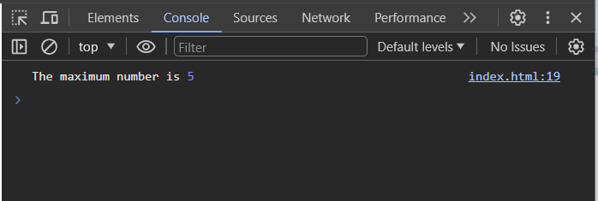

Q.27 Write to find minimum number among 3 number using ternary operator in js?

ANS :

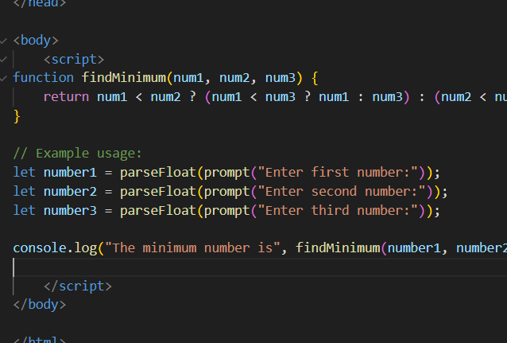

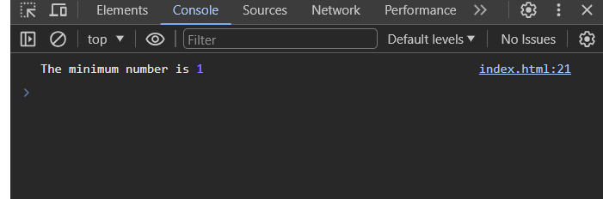

Q.28 Write to find the largest of three number in js?

ANS :

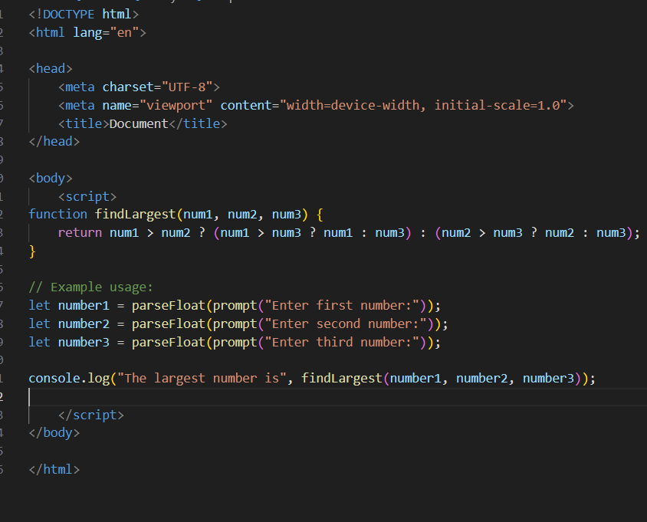

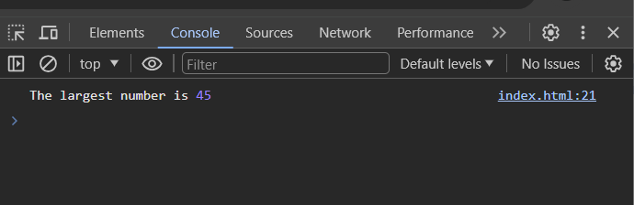

Q.29 Write to show

1. Monday to Sunday using switch case in JS ?

ANS :

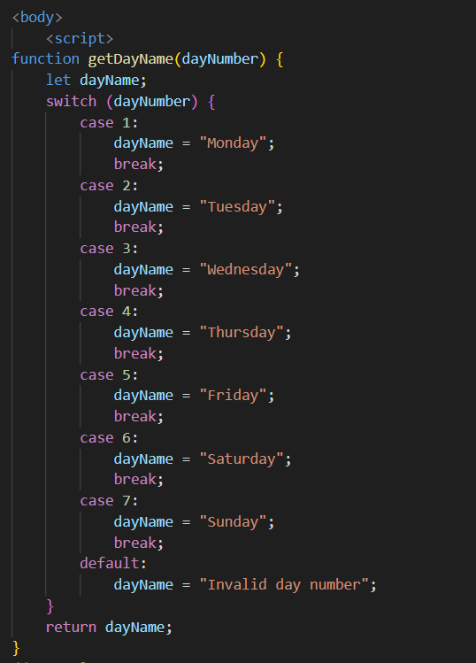

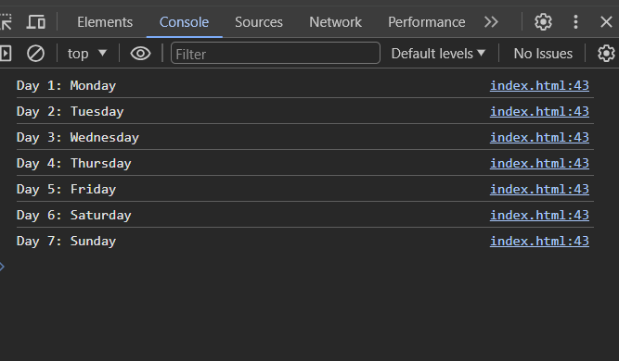

ii. Vowel or Consonant using switch case in JS?

ANS :

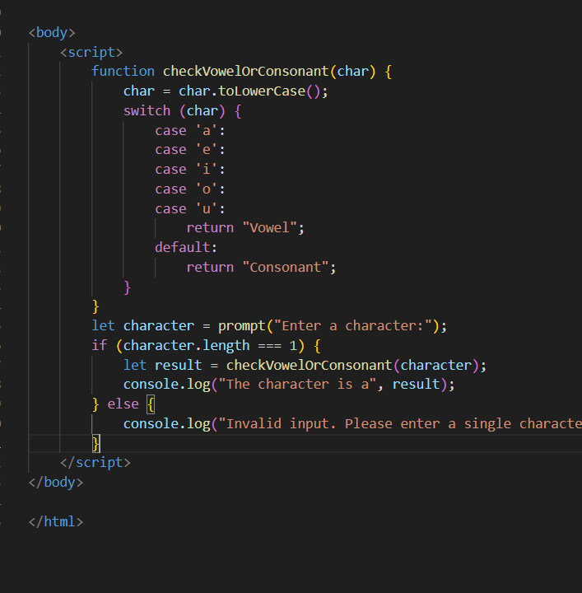

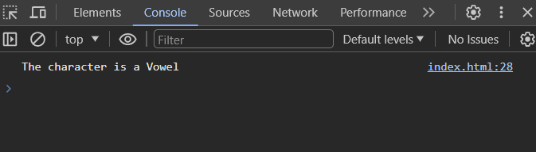

(Conditional looping logic Question)

Q.30 What are the looping structures in javascript? any one example?

ANS :

Looping structures in JavaScript are used to execute a block of code repeatedly until a certain condition is met. There are three main types of looping structures in JavaScript

for loop: Executes a block of code a specified number of times.

while loop: Executes a block of code while a specified condition is true.

do...while loop: Similar to the while loop, but the block of code is executed at least once, even if the condition is false.

Q.31 Write a print 972 to 897 using for llop in js?

ANS :

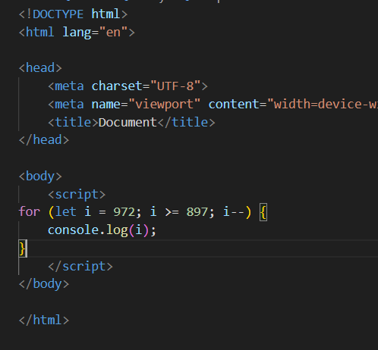

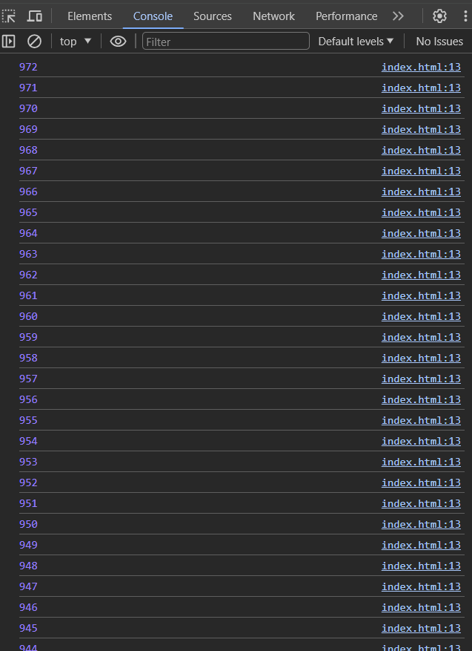

Q.32 Write to print factorial of given number ?

ANS :

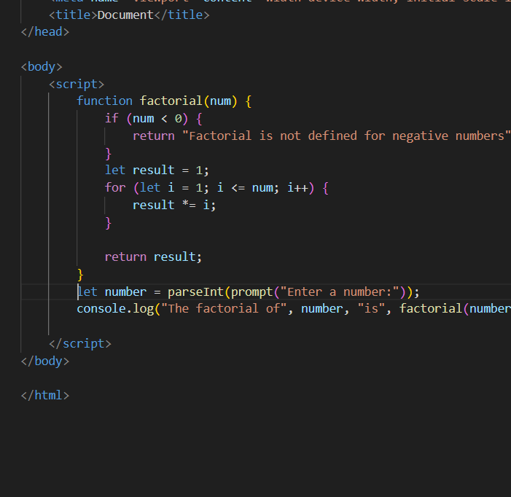

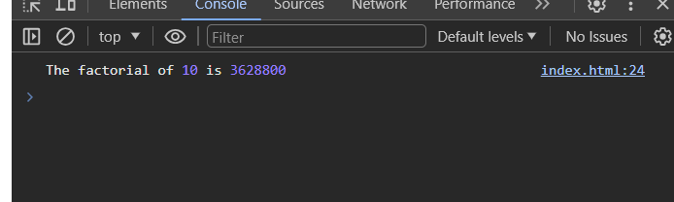

Q.33 Write to print Fibonacci series up to given numbers?

ANS :

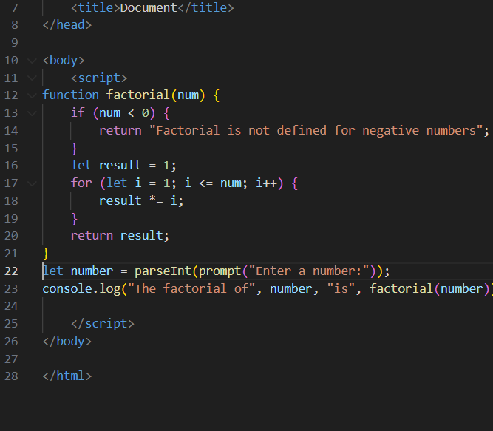

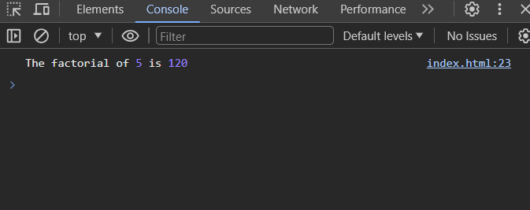

Q.34 Write to print number in reverse order e.g.: number = 64728 ---> reverse =82746 in JS?

ANS :

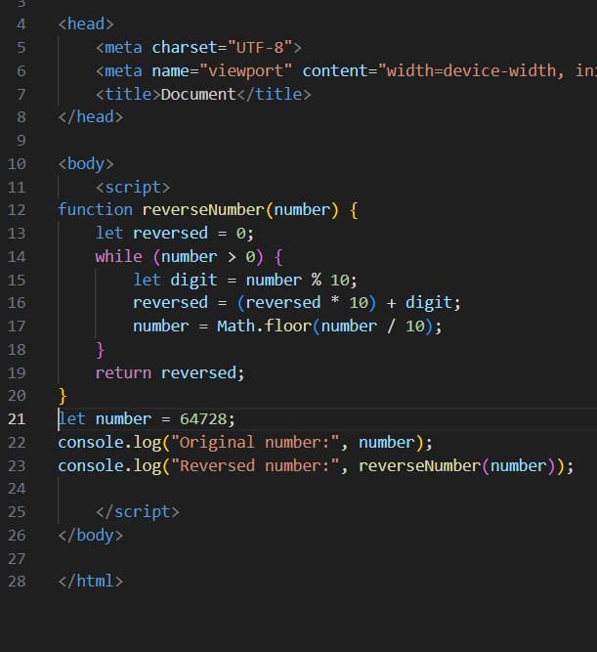

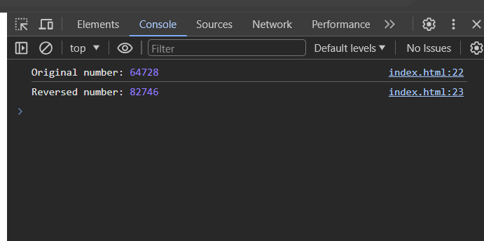

Q.35 Write a program make a summation of given number (E.g., 1523 Ans: - 11) in JS?

ANS :

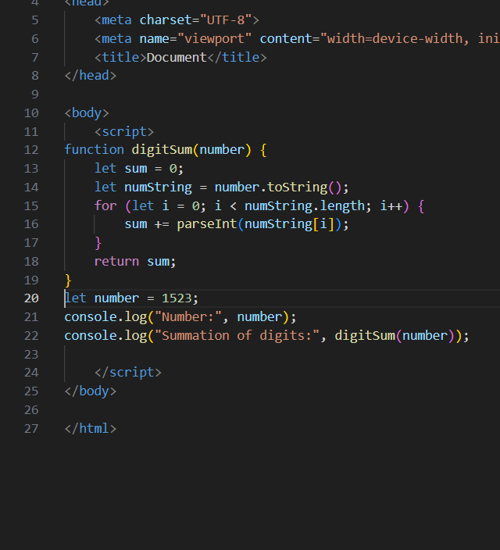

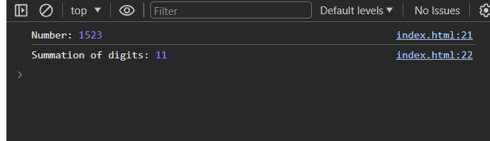

Q.36 Write a program you have to make a summation of first and last Digit. (E.g.,1234Ans: -5) in JS?

ANS :

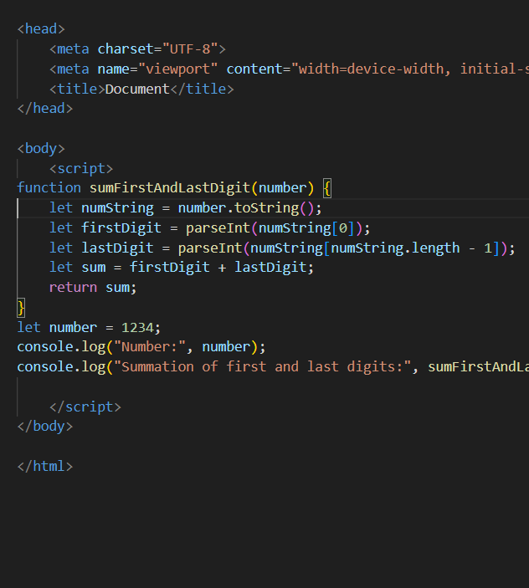

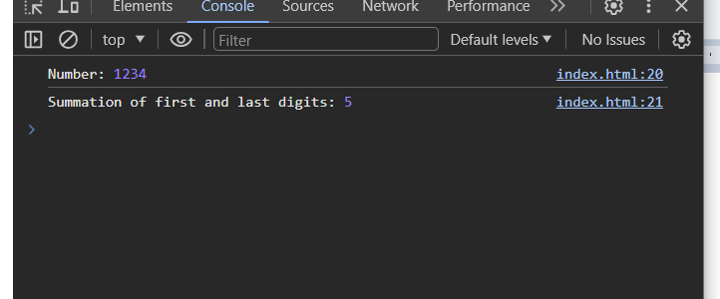

Q.37 Use console.log() and escape characters to print the following pattern in JS?

1 1 1 1 1

2 1 2 4 8

3 1 3 9 27

4 1 4 16 64

5 1 5 25 125

ANS :

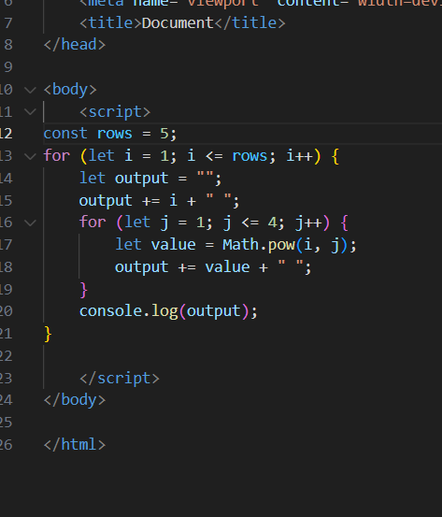

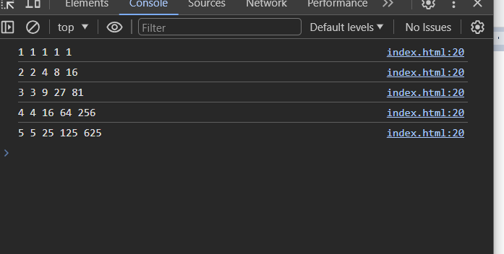

Q.38 Use pattern in console.log in JS?

1) 1

1 0

1 0 1

1 0 1 0

1 0 1 0 1

ANS :

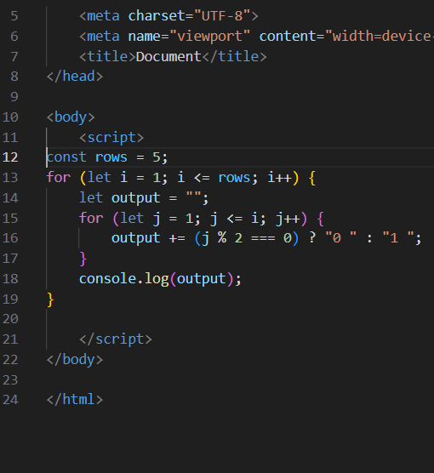

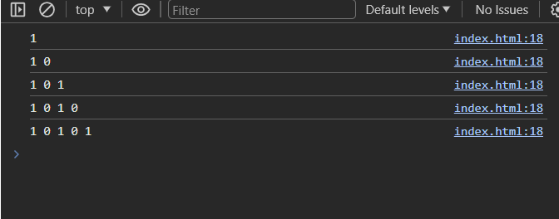

2) A

B C

D E F

G H I J

K L M N O

ANS :

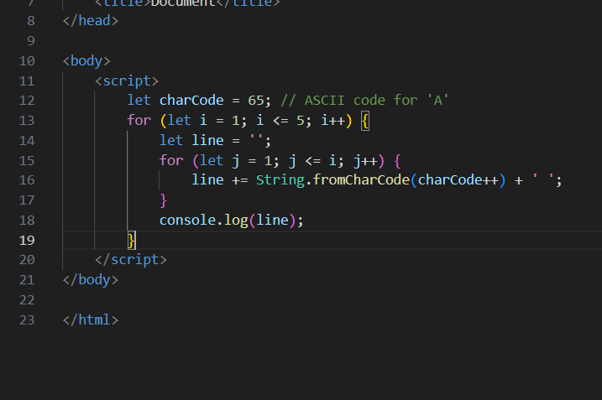

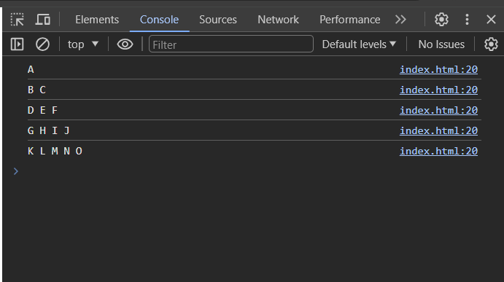

3) 1

2 3

4 5 6

7 8 9 10

11 12 13 14 15

ANS :

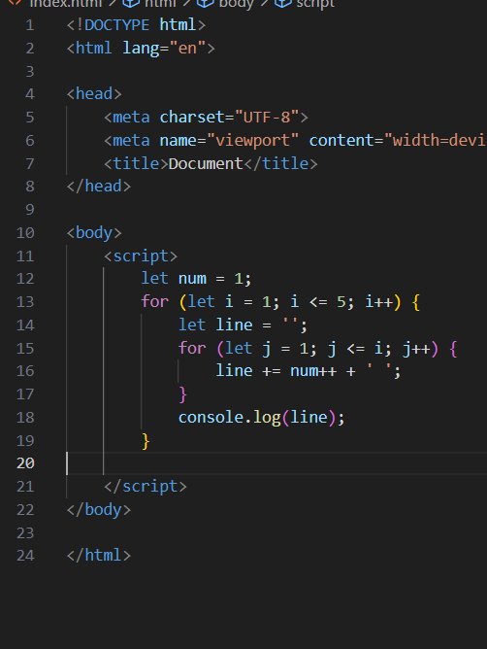

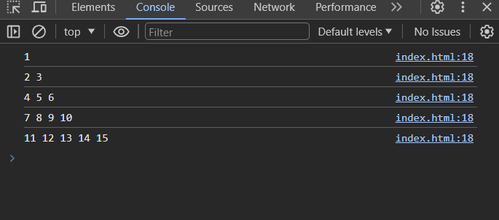

4) *

* *

* * *

* * * *

* * * * *

ANS :

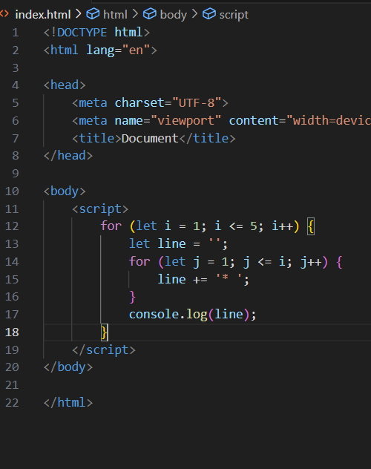

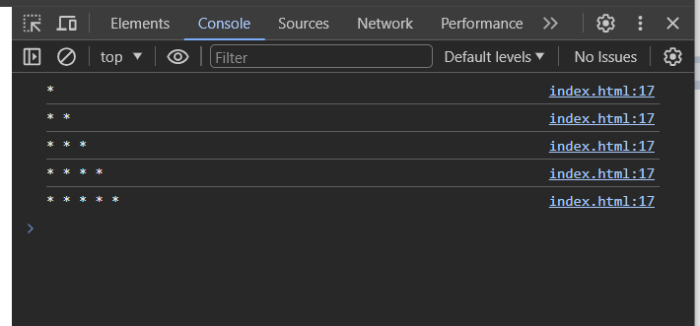

Q.39 Accept 3 numbers from user using while loop and check each numbers palindrome?

ANS :

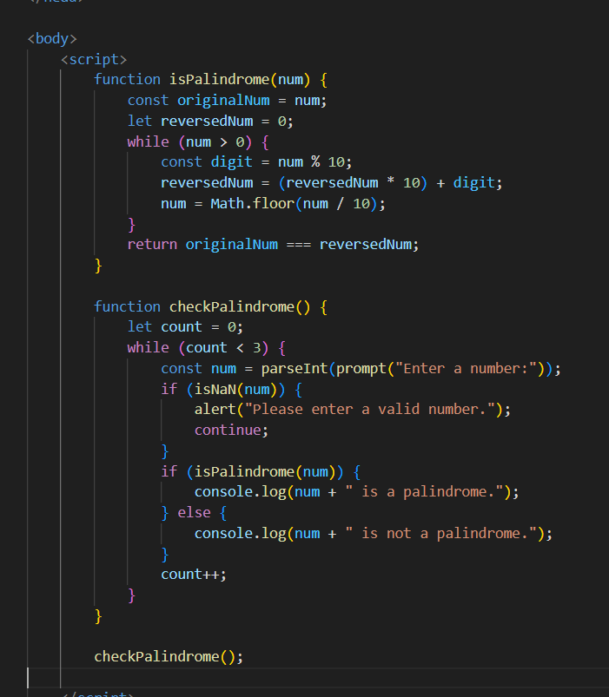

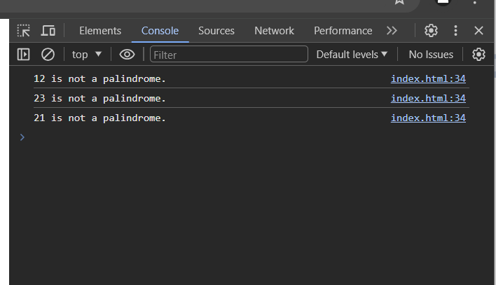

(Array and object Question)

Q.40 Write a JavaScript Program to display the current day and time in the following format.Sample Output: Today is Friday. Current Time is 12 PM: 12 : 22 2 ?

ANS :

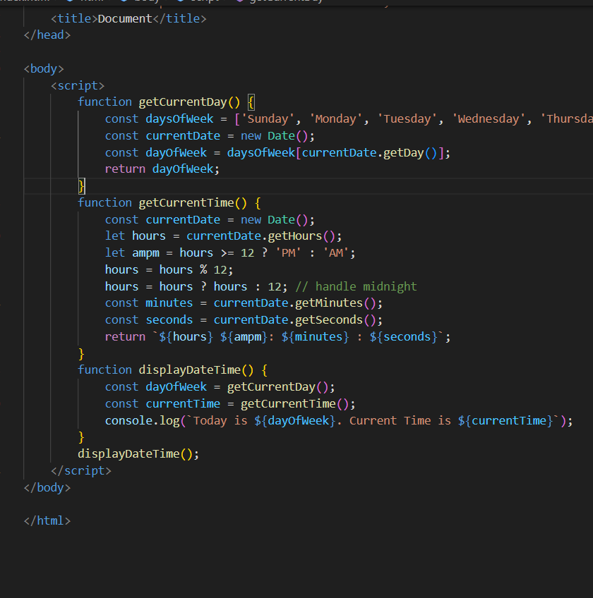

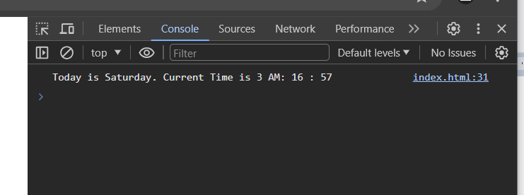

Q.41 Write a

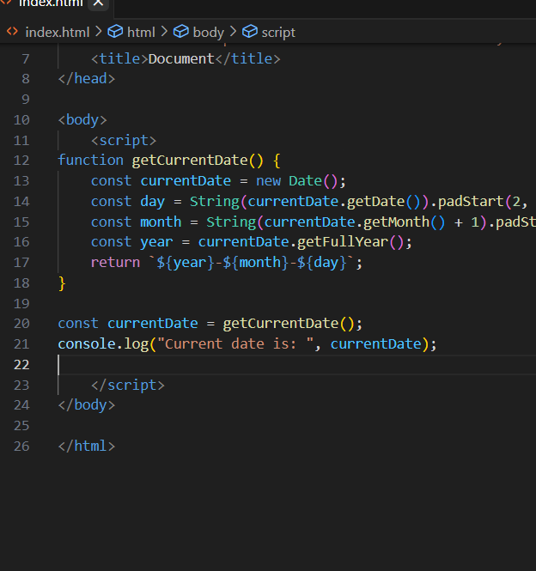

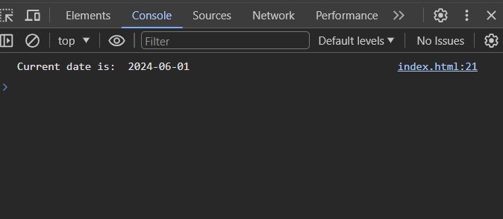

Q.42 Write a JavaScript program to compare two objects?

ANS:

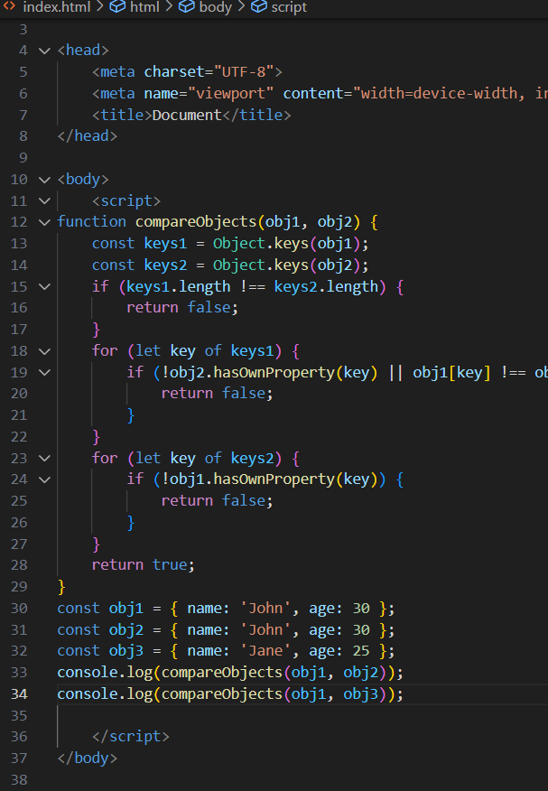

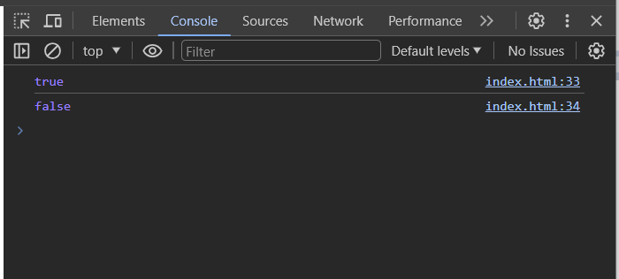.

Q.43 Write a JavaScript program to convert an array of objects into CSV string?

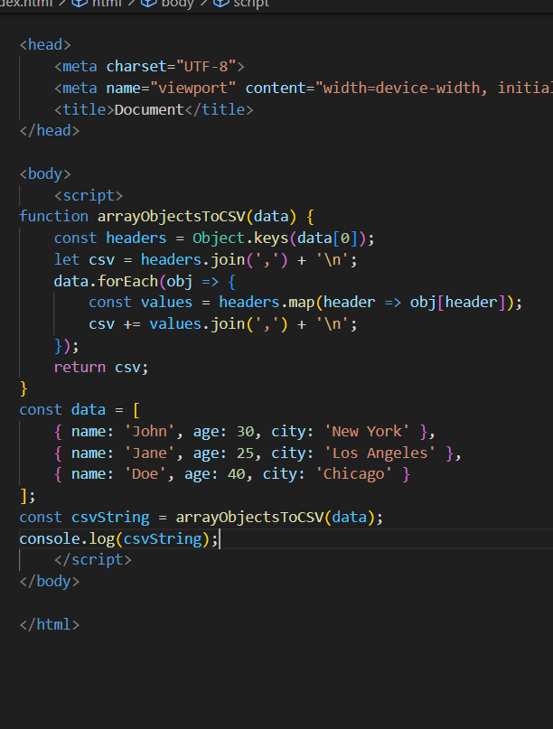

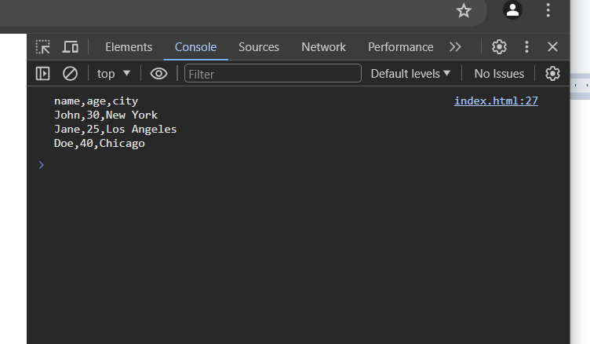

Q.44 Write a JavaScript program to capitalize first letter of a string?

ANS :

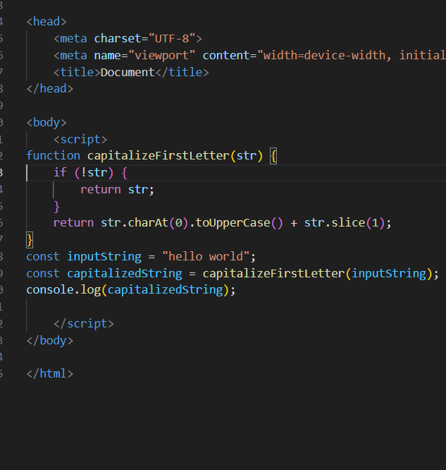

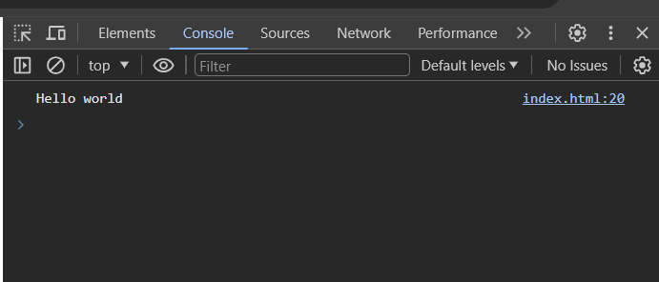

Q. 45 Write a JavaScript program to determine if a variable is array?

ANS :

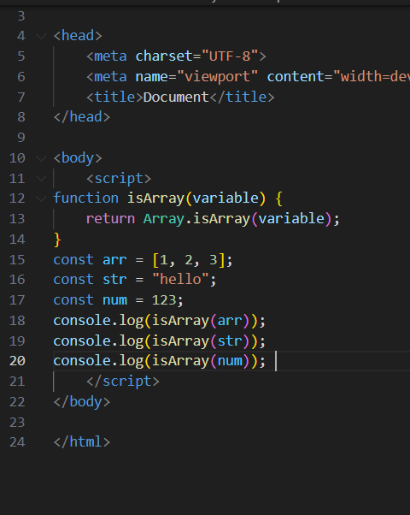

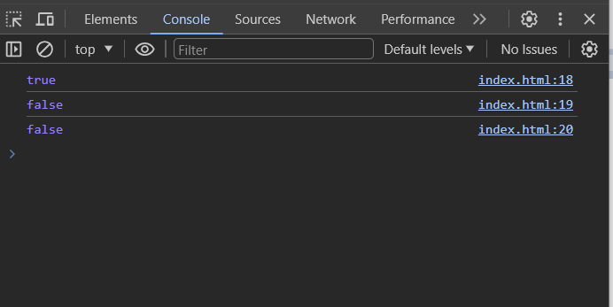

Q.46 Write a JavaScript program to clone an array?

ANS :

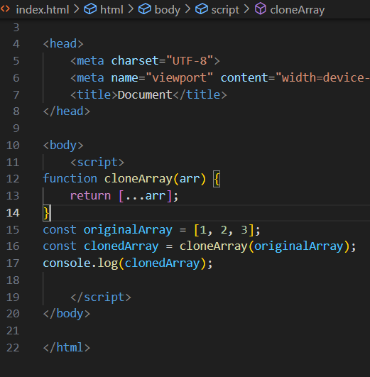

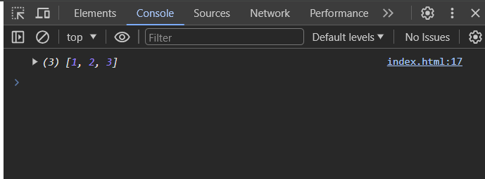

Q.47 What is the drawback of declaring methods directly in JavaScript objects?

ANS :

Performance: Each object will contain its own copy of the method, which can take up a lot of memory, especially if the object is created many times

To avoid these drawbacks, it is generally recommended to declare methods on the prototype of the object. This way, each object will share a single copy of the method, which can save memory and improve performance. Methods declared on the prototype can also be reused by other objects and are easier to maintain.

Reusability: Methods declared directly in objects cannot be reused by other objects.

Maintainability: Code can become more difficult to maintain if methods are scattered throughout different objects.

Q.48 Print the length of the string on the browser console using console.log()?

ANS :

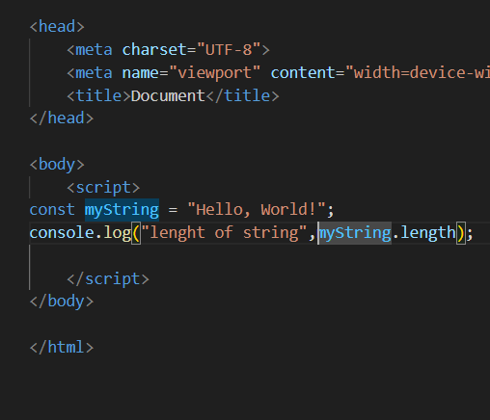

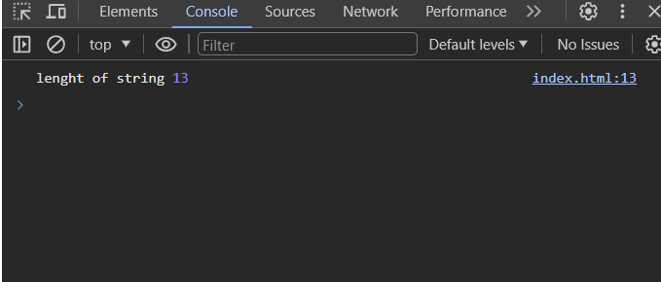

Q.49 Change all the string characters to capital letters using toUpperCase() method?

ANS :

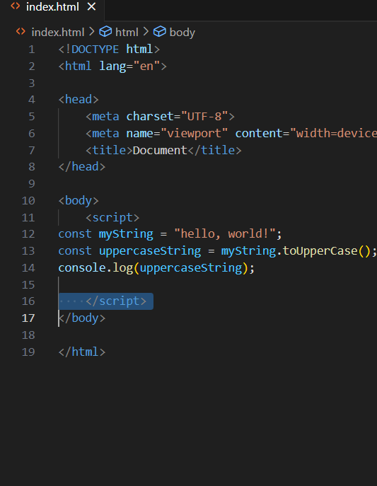

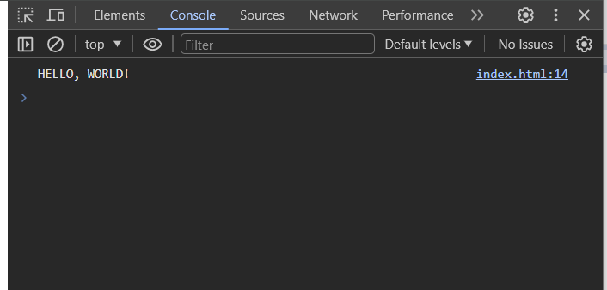

Q.50 What is the drawback of declaring methods directly in JavaScript objects?

ANS :

One drawback of declaring methods directly in JavaScript objects is that each object instance will have its own copy of the method. This can lead to increased memory consumption if there are many instances of the object, as each instance will store a separate copy of the method in memory.

To avoid this drawback, you can define methods on the prototype of the constructor function. This way, all instances of the object share the same method, reducing memory usage.By defining methods on the prototype, you ensure that each instance only needs to store a reference to the shared method, resulting in better memory efficiency.

Reusability: Methods declared directly in objects cannot be reused by other objects.

Maintainability: Code can become more difficult to maintain if methods are scattered throughout different objects.

Q.51 Write a JavaScript program to get the current date. Expected Output : mm-dd-yyyy,mm/dd/yyyy or dd-mm-yyyy, dd/mm/yyyy?

ANS :

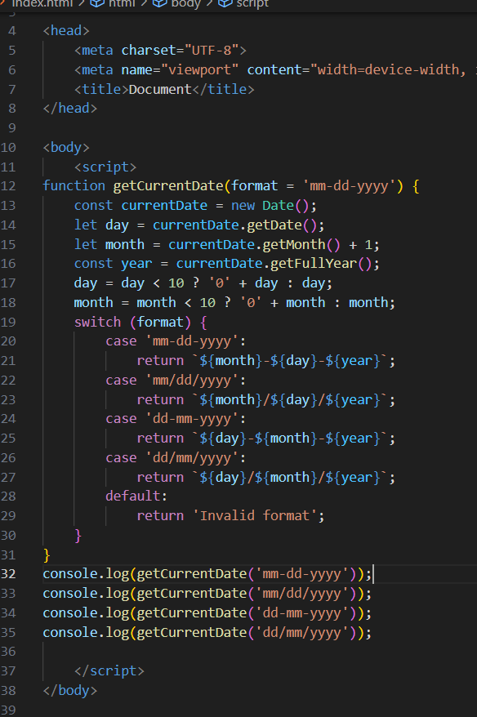

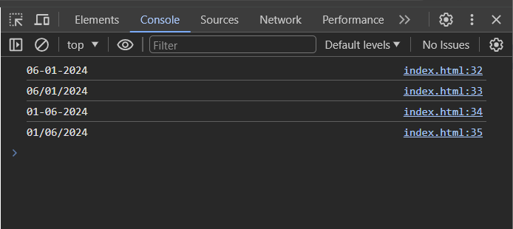

Q.52 Use indexOf to determine the position of the first occurrence of a in 30 Days Of

JavaScript?

ANS :

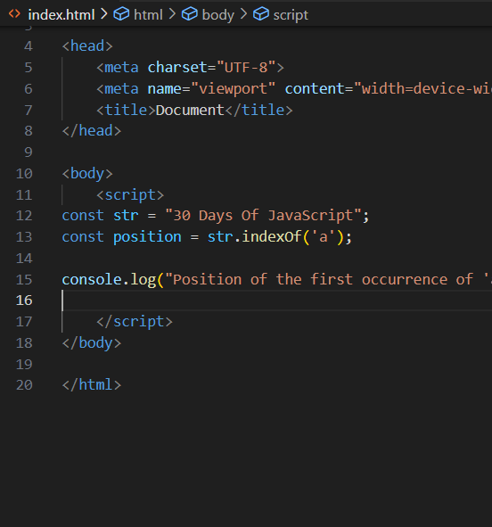

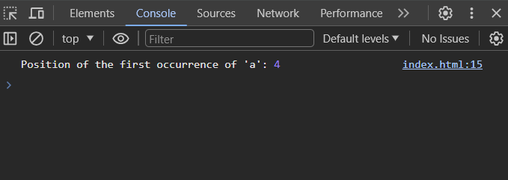

Q.53 Use lastIndexOf to determine the position of the last occurrence of a in 30 Days OfJavaScript?

ANS :

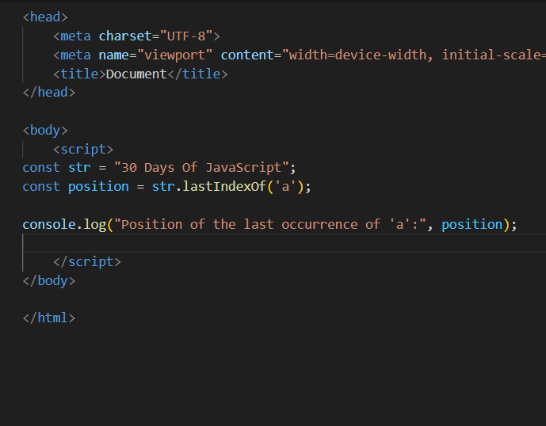

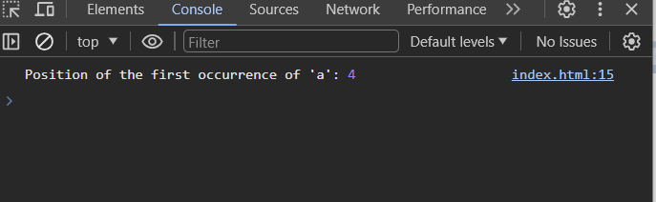

Q.54 Form Validtion in JS?

ANS :

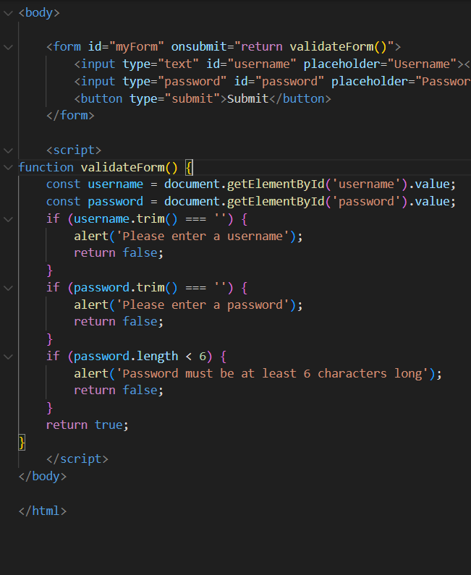

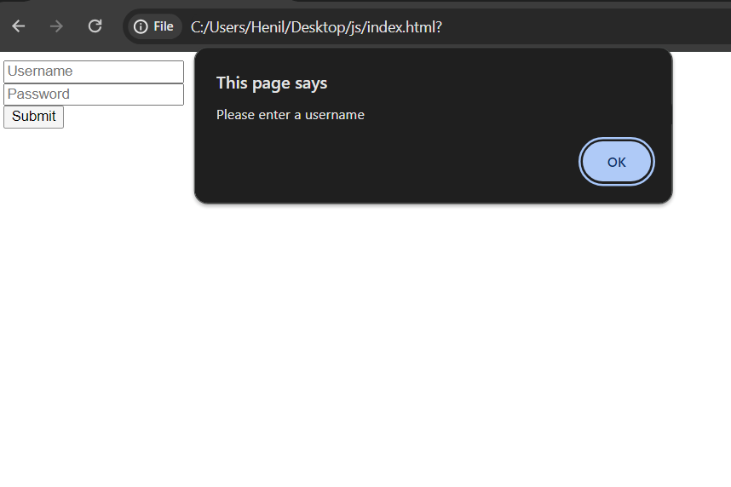

Q.55 Form in Email, number, Password, Validation?

ANS :

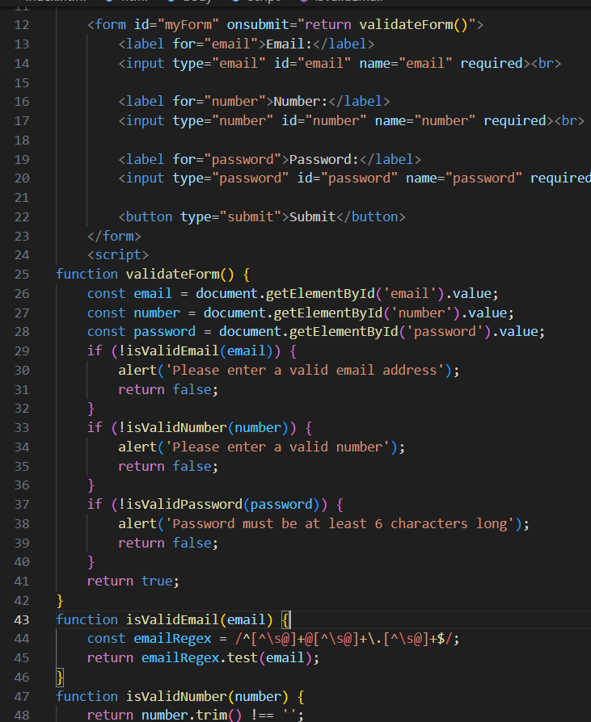

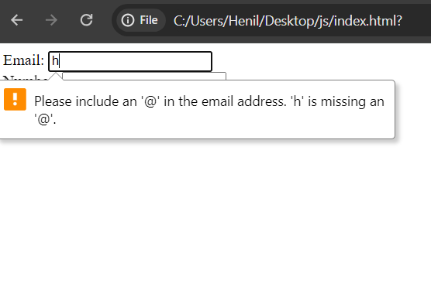

Q.56 Dynamic Form Validation in JS?

ANS :

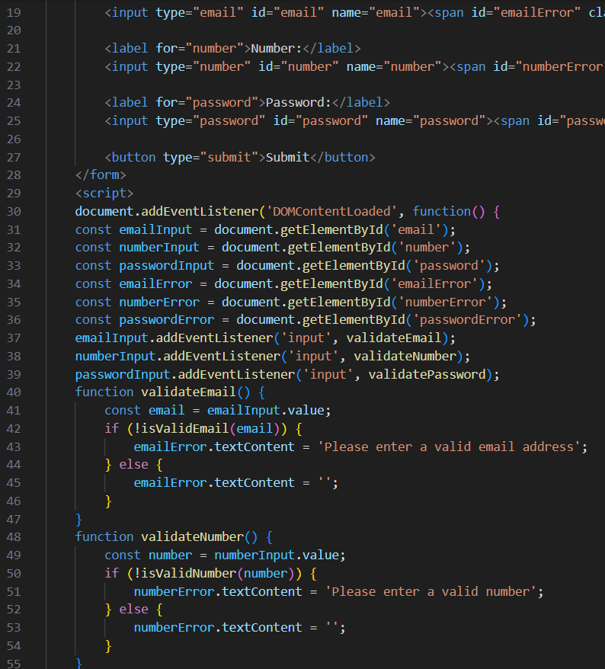

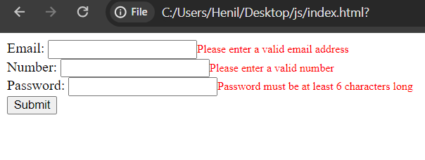

Q.57 how many type of JS Event? How to use it ?

ANS :

In JavaScript, there are several types of events that can occur, categorized based on their origins or sources. Some common types of events include:

1.Mouse Events: These events occur when the user interacts with the mouse. Examples include click, mouseover, mouseout, mousedown, mouseup, etc.

2. Keyboard Events: These events occur when the user interacts with the keyboard. Examples include keydown, keyup, keypress, etc.

3. Form Events: These events occur when the user interacts with HTML forms. Examples include submit, change, focus, blur, etc.

4. Document/Window Events: These events occur on the document or window object. Examples include load, DOMContentLoaded, scroll, resize, etc.

5. Touch Events: These events occur when the user interacts with a touchscreen device. Examples include touchstart, touchmove, touchend, etc.

Q.58 What is Bom vs Dom in JS?

ANS :

1. DOM (Document Object Model):

* The DOM represents the structure of an HTML document as a tree-like structure of nodes, where each node corresponds to an element, attribute, or text within the document.
* The DOM provides a programming interface for web developers to manipulate the structure, content, and style of HTML documents dynamically using JavaScript.
* Examples of DOM manipulation methods include getElementById(), querySelector(), createElement(), appendChild(), setAttribute(), etc.

2.BOM (Browser Object Model):

* The BOM represents the browser window and its components, providing a set of objects and methods that allow JavaScript to interact with the browser environment.
* Unlike the DOM, which focuses on the structure and content of HTML documents, the BOM focuses on browser-specific features and functionalities, such as managing browser windows, controlling navigation, handling cookies, and interacting with the browser history.
* The BOM includes objects like window, navigator, location, history, screen, document, etc., which provide access to various aspects of the browser and the user's browsing session.

Q.59 Array vs object defences in JS?

ANS :

1. Arrays:

* Strengths: Arrays are ideal for storing ordered collections of elements and performing operations like iteration, sorting, and filtering efficiently.
* Weaknesses: Arrays may not be suitable for representing structured data with named properties. Also, accessing elements by index can be error-prone if indices are misused or out of bounds.

**2**. Objects:

* Strengths: Objects provide a flexible and versatile way to represent structured data with named properties. They are excellent for organizing related data and behavior into cohesive units.
* Weaknesses: Objects lack the inherent order of arrays, making them less suitable for scenarios where element order is significant. Additionally, excessive nesting of objects can lead to complex and hard-to-maintain code.

Q.60 Split the string into an array using split() Method?

ANS :

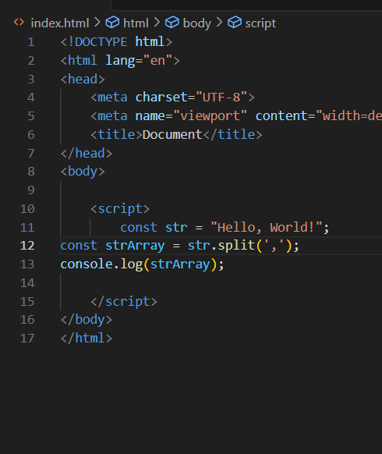

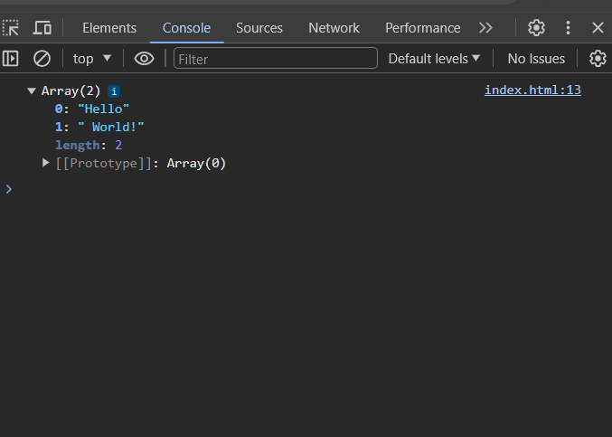

Q.61 Check if the string contains a word Script using includes() method?

ANS :

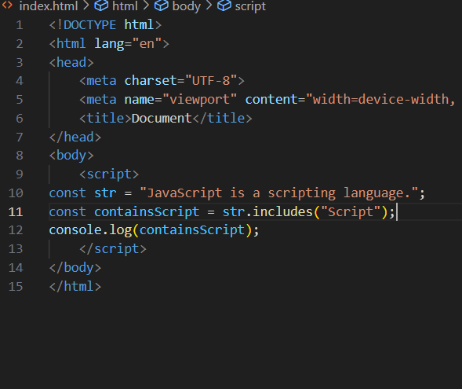

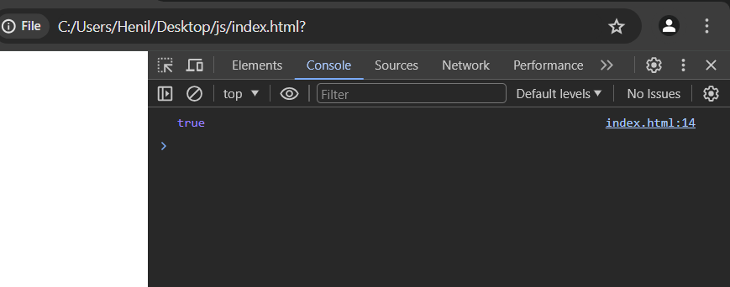

Q.62 Change all the string characters to lowercase letters using toLowerCase() Method.

ANS :

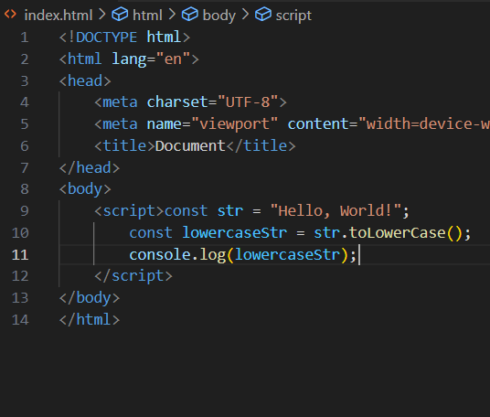

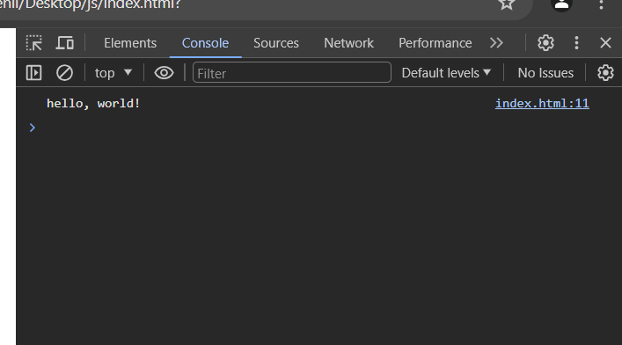

Q.63 What is Character at index 15 in ’30 Days of JavaScript’ string? Use charAt() method.

ANS :

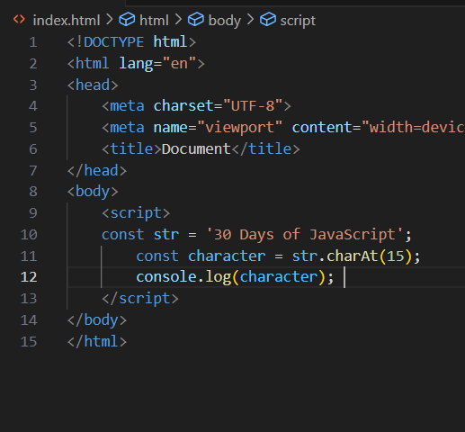

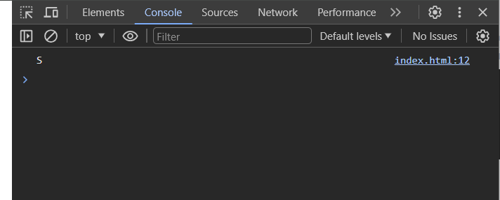

Q.64 copy to one string to another string in JS?

ANS :

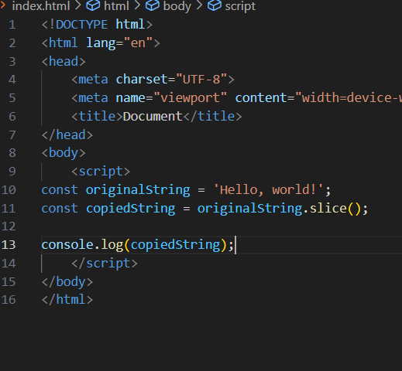

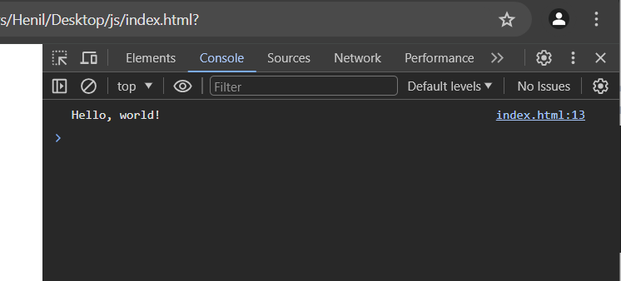

Q.65 What is JavaScript?

ANS **:**

JavaScript (JS) is a high-level, interpreted programming language that is one of the core technologies of the World Wide Web, alongside HTML and CSS. JavaScript enables interactive web pages and

Q.66 What is negative Infinity?

ANS **:**

NEGATIVE_INFINITY is a special numeric value that is returned when an arithmetic operation or mathematical function generates a negative value greater than the largest representable number in JavaScript (i.e., more negative than -Number. MAX_VALUE). JavaScript displays the NEGATIVE_INFINITY value as -Infinity.

Q.67 Which company developed JavaScript?

ANS :

JavaScript was created at Netscape Communications by Brendan Eich in 1995. Netscape and Eich designed JavaScript as a scripting language for use with the company's flagship web browser, Netscape Navigator.

Q.68 What are undeclared and undefined variables?

ANS :

* Undeclared variablesare variables that have not been declared using the var, let, or const keyword. Trying to access an undeclared variable will throw a Reference Error.
* Undefined variablesare variables that have been declared but have not been assigned a value. The value of an undefined variable is undefined.

Q.68 Write the code for adding new elements dynamically?

ANS :

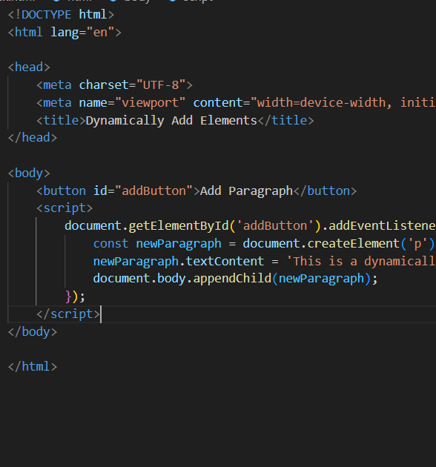

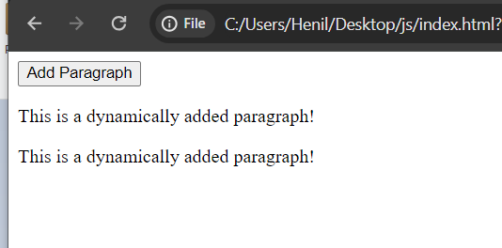

Q.69 What is the difference between ViewState and SessionState?

ANS :

ViewState and SessionState are both concepts used in ASP.NET for managing state information, but they serve different purposes and are used in different contexts. Here's a brief explanation of each:

1.ViewState:

* ViewState is a client-side state management technique used in ASP.NET Web Forms applications.
* It is used to persist the state of a page across postbacks (i.e., when a form is submitted or a button is clicked).
* ViewState stores data in a hidden field (<input type="hidden">) within the HTML output of the page. This hidden field is then sent back and forth between the client and server in subsequent requests, allowing the server to reconstruct the page's state.

2.SessionState:

* SessionState is a server-side state management technique used to persist user-specific data across multiple requests within the same user session.
* It stores data on the server, typically in memory (in-process), in a separate process (out-of-process), or in an external storage mechanism (e.g., SQL Server).
* SessionState allows you to store and retrieve data associated with a user's session, such as user authentication details, shopping cart contents, or user preferences

.

Q.70 What is === operator?

ANS :

The === operator in JavaScript is called the strict equality operator. It compares two values, checking both their equality and their data types. It returns true if the values are equal and of the same type, and false otherwise.

Q.71 How can the style/class of an element be changed?

ANS :

document.getElementById("myElement").style.color = "red";

Q.72 How to read and write a file using JavaScript?

ANS :

readFile() and rs. writeFile() methods are used to read and write of a file using javascript. The file is read using the fs. readFile() function, which is an inbuilt method.

Q.73 What are all the looping structures in JavaScript?

ANS :

The statements for loops provided in JavaScript are:

* for statement.
* do...while statement.
* while statement.
* break statement.
* continue statement.

Q.74 How can you convert the string of any base to an integer in JavaScript?

ANS :

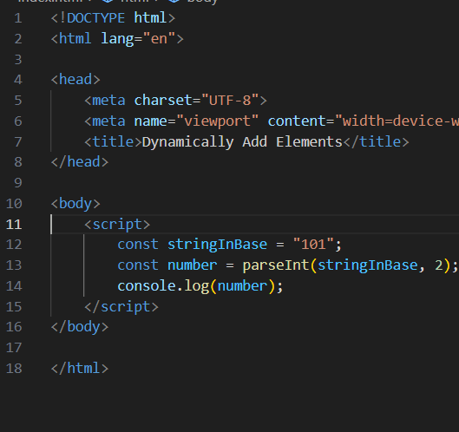

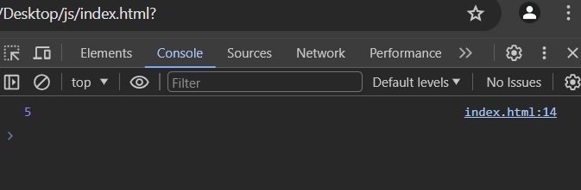

Q.75 What is the function of the delete operator?

ANS :

In JavaScript, the delete operator is used to remove a property from an object or an element from an array. Its primary function is to delete a specific property of an object, but it can also be used to remove elements from an array.

Q.76 What are all the types of Pop up boxes available in JavaScript?

ANS :

1. Alert Box:

The alert() method displays a modal dialog box with a message and an OK button. It is typically used to display an informational message to the user.

2. Confirm Box:

The confirm() method displays a modal dialog box with a message, along with OK and Cancel buttons. It is used to ask the user for confirmation before proceeding with an action.

3.Prompt Box:

The prompt() method displays a modal dialog box with a message, an input field for the user to enter text, along with OK and Cancel buttons. It is used to prompt the user for input, such as asking for their name or entering a value.

Q.77 What is the use of Void (0)?

ANS :

The void operator evaluates an expression and returns undefined . By running void(0) in the URL JavaScript code**,**nothing is evaluated or returned.

Q.78 How can a page be forced to load another page in JavaScript?

ANS :

Navigate to a new page by setting window.location.href to the URL of the new page

window.location.href = "<https://example.com/newpage>";

Q.79 What are the disadvantages of using innerHTML in JavaScript?

ANS **:**

It is very slow because as inner HTML already parses the content even we have to parse the content again so that's why it takes time.

Q.80 Create password field with show hide functionalities

ANS :

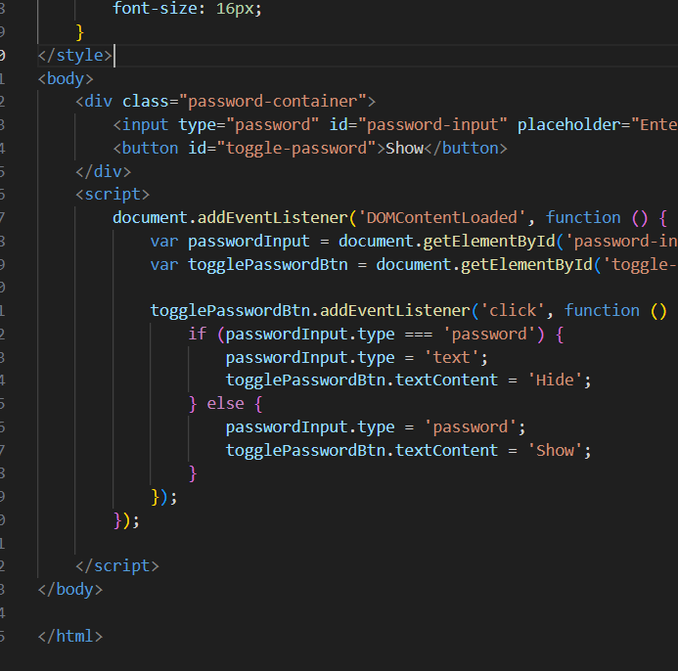

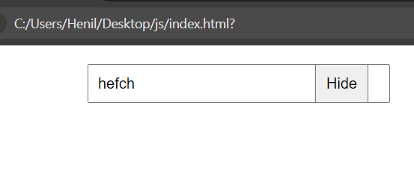

Q.81 reate basic math operation in JS

ANS :

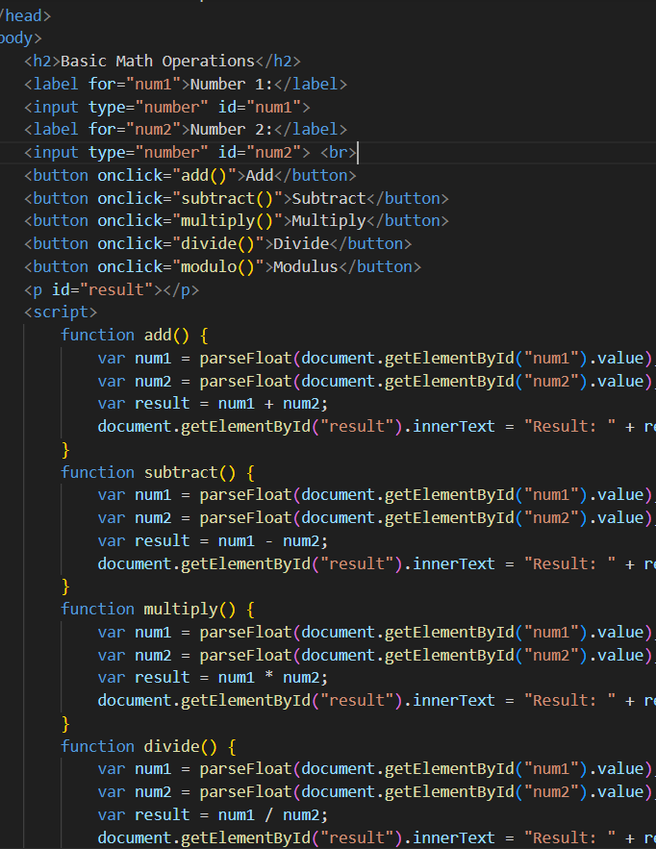

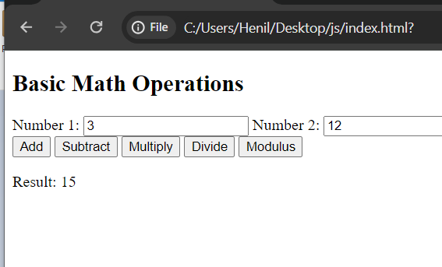

Q.82 Create result

ANS :

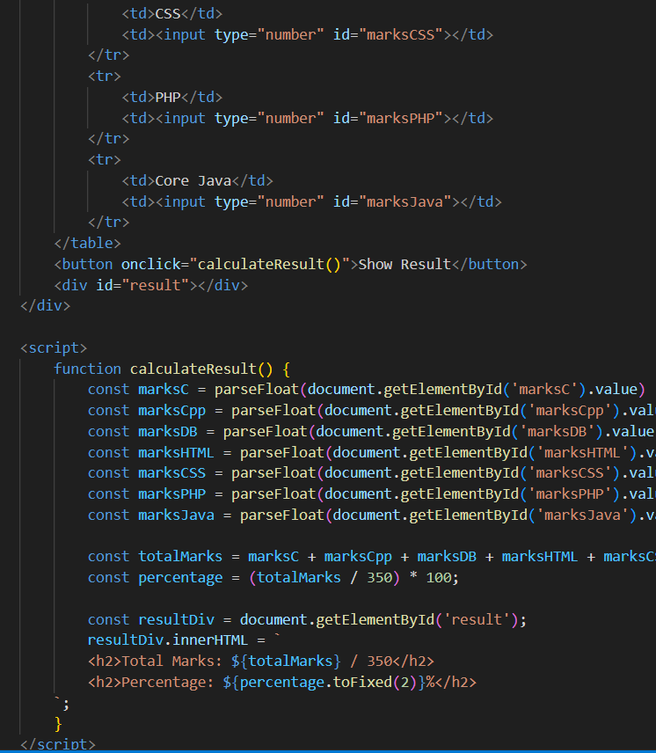

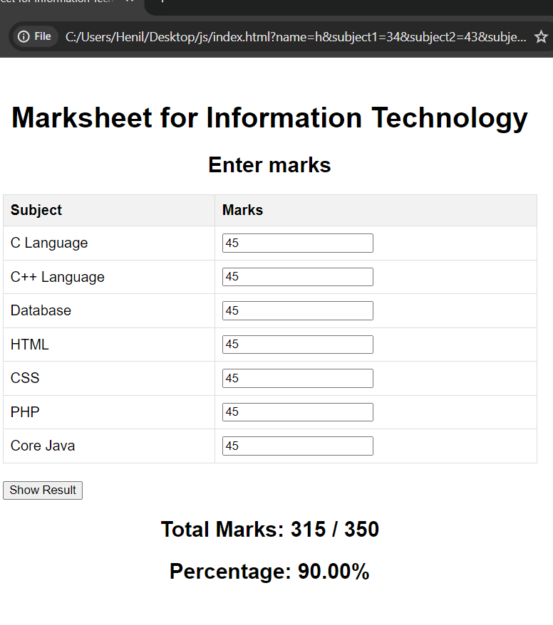

Q.83 Create a slider using JavaScript

ANS :

